CS 255 Business Requirements Document

DriverPass
Jessica Johnson- SNHU CS255
2/8/2025

System Components and Design

Purpose
- DriverPass has a vision for a new system that trains students for their driving test.
- The purpose of the project is to provide better training for people learning how to drive and preparing them for their exam at the DMV.

System Background
- DriverPass needs a system that allows drivers to take online lessons and practice tests.
- DriverPass aims to fix the high percentage of drivers failing their driver tests at the DMV with their online driver learning platform.
- The system requires an online platform for uploading learning materials and taking practice tests. It must also be able to handle appointment setting for their on-the-road training. There should also be security measures to include different levels of users with limited functionality/access.

Objectives and Goals
- The system should have different levels of users with different access depending on role and needs. Owner, IT, Secretary, User, Driver will all have different levels of access.
- New User creation (obtain Name, address, phone, email.)
- Have a home screen that shows the users Online test progress, Driver notes, Information, Special needs, Driver Photo, and Student Photo.
- Allow access to learning materials and tests.
- Track learning progress of user throughout course.
- Allow users to see the on-the-road training schedule and make an appointment. The user will select package and schedule a session. (Payment and pickup/drop-off location will be obtained.)
- Users can call for reservations as well.
- Track driver schedules (driver, user, time, car)
- Drivers should be allowed to submit notes that will be displayed on the user’s homepage.
- The system must also be able to allow for password resets for minimal maintenance.
- The system will be connected to the DMV to allow for updated materials.

Requirements

Nonfunctional Requirements

Performance Requirements
- The system must run off the web, preferably the cloud.
- The speed of the system must support real time test results and real time appointment book updates.
- DriverPass also needs to be able to implement changes to its own system based off the linked DMV compliance.
- The system should update often, due to the need for DMV compliance and real time test taking and appointment setting.

Platform Constraints
- The system will run on Windows.
- It should also be connected with the cloud to eliminate the need for backup and extra security.

Accuracy and Precision
- There will be 4 main types of users in the system: Admin, Staff, Driver, and Student
- When each user creates a profile a user type is associated with them, and they are given appropriate permissions based off the need of their role in the system
- The user input is case sensitive
- The system will inform the admin of a problem such as a password lockout or a terminated employee who needs their access turned off.
- Analytics and Reports can be pulled by admin.

Adaptability
- If changes need to be made to the user, an admin can do all tasks without changing the code. Staff can add and modify users.
- Admin can disable packages if needed.
- If platform updates are needed, the system should be updated as needed. An IT admin can assist as needed.
- The IT admin needs full access to the system, no restrictions.

Security
- For User to Login, they must enter a case sensitive username and password with a 2-factor authentication at registration
- Secure the connection by encrypting the data before sending it to the server.
- Keep/maintain a high-quality security system.
- After a user enters an incorrect password too many times, their profile is locked, and they must contact the company to verify their account. This helps prevent “brute force” hacking attempts.
- All admins are notified if multiple lockouts happen within a specified time frame.

Functional Requirements
- The system shall validate user credentials when logging in.
- The system shall proceed with security measures if invalid login attempts occur.
- The system shall allow admin and staff the ability to add and modify users.
- The system shall provide learning materials and exams to the students.
- The system shall keep track of scores and completed coursework.
- The system shall allow users to make appointments for in person driving courses.
- The system shall allow drivers to see the schedule.
- The system shall allow drivers to select and pay for packages.
- The system shall allow admin to pull reports and system analytics.
- The system shall contain only the most up-to-date coursework based on real time connections to DMV compliance sites.

User Interface
- User Friendly interface that has mobile and web capabilities.
- Home Screen that gives an overview of the students’ progress (in-progress, failed, or passed), their information (first name, last name, address, city, state, zip, phone, email, and payment info), driver notes, special needs, driver photo, and student photo.
- Driver Notes- contain lesson time, start/end time, and driver comments.
- Input Form-student info as described above
- Contact Us/Contact Student- way to get in contact with admin, driver, staff, or the student
- Admin/IT Admin: Must be able to see all information. They also must be able to edit profiles, unlock accounts, change appoint times, edit approved users, and comment on any comment sections of the interface.
- Staff: Can see driver schedules and modify appointments.
- Driver: Can view schedules and make comments on the driver notes.
- Student: Modify appointment times, profile information, and access online coursework.

Assumptions
- Users have access to mobile or web applications.
- User speaks English. Should we implement a Spanish version?
- DMV will allow direct access to compliance changes.
- Admin IT is on-call to ensure security of system.
- Users’ mobile devices are compatible with the mobile app.

Limitations
- Budgets were never discussed. We could go over budget or way under and under-deliver.
- Small company: Customer support/System maintenance may become too much for one person as an IT Admin.

Gantt Chart
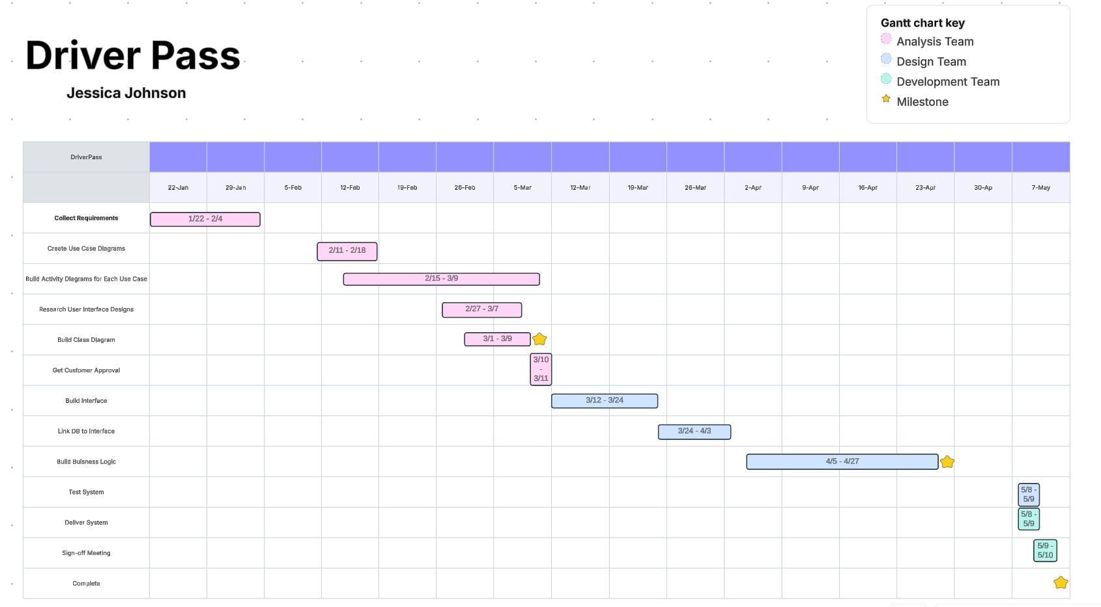

Grade 88.75/100
Suggestions

Your Business Requirements Document was well written. I included some suggestions and clarification for the non-functional requirements, assumptions and limitations sections. You confused the iterative software development methodology with a process model. A process model would be a DFD for example. It describes the flow of data through a system. Please review the rubric for specific feedback and grading.

You did a good job on the purpose, system background and goals and objectives. The entry for each is clear and contains pertinent information about the system that is to be built. You identified the client and the problem they are trying to solve.

You provided a complete list of functional and non-functional requirements. You should include measurable targets when appropriate. For example, the performance requirement should define a page response or load time. The security requirement should say how many incorrect passwords locks an account. You would review this with your client to confirm you are on the same page. You have a good set of functional requirements.

You did a good job identifying the content/pages that would exist in the interface. You identified the Admin/IT Admin, Staff, Driver and Student user roles that would need to use the interface. You identified requirements for each of the user roles.

You provided some good assumptions. You should assume the system will only be in English rather than ask a question within the assumptions. Admin's being on call for security is a business decision outside the scope of your project. You would want to make sure budget was discussed rather than document it as a limitation. Customer support is also a business decision outside the scope of your project. Limitations are risks, which if realized will impact your project delivery. A limitation could be that the requested delivery date is too tight to accommodate any scope changes without delaying delivery.

The iterative model is a software development methodology not a process model. A process model describes the flow of data through a system. An example would be a DFD. You did a good job describing object models. You used valid examples from the DriverPass interview to illustrate how it would be applied.

You compared an iterative development methodology to an object model. The process model shows the flow of data from beginning to end. It does not describe the data. The object model describes the data very well. It does not give an order to the activity. It does not have a beginning or end. Ultimately, they each contribute to defining the system so it is ideal if both are created to complement each other and provide the full picture of the system.

